Pinewood Timer Board V2.x
Instructions online at http://pinewood.hmpg.net

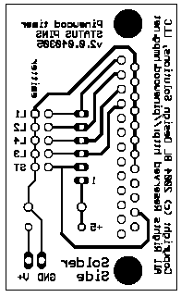
Back of Board (Reversed)

This is the back of the board as though you were looking right through the board (now you know what Superman sees).

Actual size
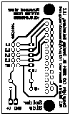

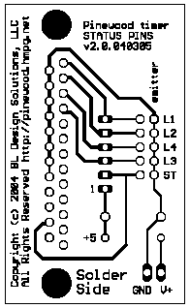
Back of Board Normal

This is the back of the board as you would actually see it if you flip it over. Notice that NO COMPONENTS go on this side. Note the order of the lane connections from top to bottom. Lanes 3 and 4 are out of order and the start gate is at the bottom.

Actual size
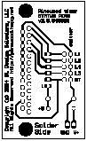

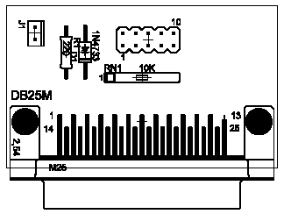
Silk Screen for Front of Board

This is not actually printed on the board but it shows where the components go on the board. Note that ALL THE COMPONENTS go on this side, not the solder side. Of special interest is the orientation of the Zener Diode (D1) with the black band toward the DB25 connector.

